Assignment 1

**16C:**   
T = 1 / f = 1 / (140 KHz) = 0.00000714 s = 7.14×10-6 s = 7.14 μs

**17B:**

f = 1 / T = 1 / (12 μs) =83333 Hz = 83.333 × 10

3

Hz = 83.333 KHz

**18C:**

90 degrees (π/2 radian)

**19.**

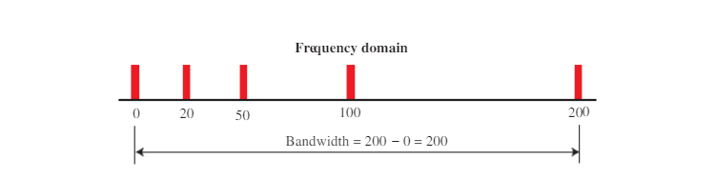

**20.** We know the lowest frequency, 100. We know the bandwidth is 2000. The highest

frequency must be 100 + 2000 = 2100 Hz. 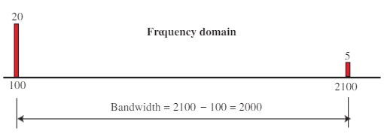

**21.** Each signal is a simple signal in this case. The bandwidth of a simple signal is

zero. So the bandwidth of both signals are the same.

**24.** There are 8 bits in 16 ns. Bit rate is

= 8 / (16 × 10^−9) = 0.5 × 10^−9

= 500 Mbps

**26.** The bandwidth is

= 5 × 5 => 25 Hz.

**29.**

Using the first harmonic, data rate = 2 × 6 MHz = 12 Mbps

Using three harmonics, data rate = (2 × 6 MHz) /3 = 4 Mbps

Using five harmonics, data rate = (2 × 6 MHz) /5 = 2.4 Mbps

**30.** dB = 10 log

10

(90 / 100) = –0.46 dB

**32**. The total gain is 3 × 4 = 12 dB. The signal is amplified by a factor 10

1.2

= 15.85.

**37.** We have 4,000 log2

(1 + 10 / 0.005) = 43,866 bps

**38.** The file contains 2,000,000 × 8 = 16,000,000 bits. With a 56-Kbps channel, it takes

16,000,000/56,000 = 289 s. With a 1-Mbps channel, it takes 16 s.

**42.** We can approximately calculate the capacity as

a. C = B × (SNRdB/3) = 20 KHz × (40 /3) = 267 Kbps

b. C = B × (SNRdB/3) = 200 KHz × (4 /3) = 267 Kbps

c. C = B × (SNRdB/3) = 1 MHz × (20 /3) = 6.67 Mbps

**43.**

a. The data rate is doubled (C2= 2 × C1).

b. When the SNR is doubled, the data rate increases slightly. We can say that, approximately, (C2= C1+ 1).

**47.**

a. Number of bits = bandwidth × delay = 1 Mbps × 2 ms = 2000 bits

b. Number of bits = bandwidth × delay = 10 Mbps × 2 ms = 20,000 bits

c. Number of bits = bandwidth × delay = 100 Mbps × 2 ms = 200,000 bits

**48.**

We have

Latency = processing time + queuing time +

Transmission time + propagation time

Processing time = 10 × 1 μs = 10 μs = 0.000010 s

Queuing time = 10 × 2 μs = 20 μs = 0.000020 s

Transmission time = 5,000,000 / (5 Mbps) = 1 s

Propagation time = (2000 Km) / (2 × 10^8) = 0.01 s

Latency = 0.000010 + 0.000020 + 1 + 0.01 = 1.01000030 s

The transmission time is dominant here because the packet size is huge.

**Chap#4:**

**15.**

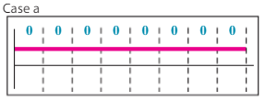

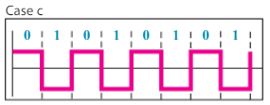

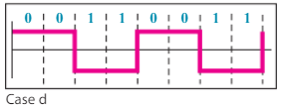

**18.**

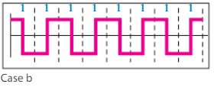

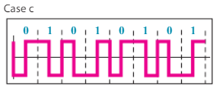

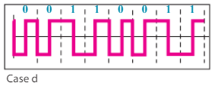

21.

The data stream can be found as

a. NRZ-I: 10011001.

b. Differential Manchester: 11000100.

c. AMI: 01110001.

28.

a. In a low pass signal, the minimum frequency is 0. Therefore, we can say

fmax= 0 + 200 = 200 KHz → fs

= 2 × 200,000 = 400,000 samples/s

The number of bits per sample and the bit rate are

nb= log21024 = 10 bits/sample N = 400 KHz × 10 = 4 Mbps

b. The value of nb= 10. We can easily calculate the value of SNRdB

SNRdB= 6.02 × nb+ 1.76 = 61.96

c. The value of nb= 10. The minimum bandwidth can be calculated as

BPCM = nb× Banalog= 10 × 200 KHz = 2 MHz

30. We can first calculate the sampling rate (fs) and the number of bits per sample (nb)

fmax= 0 + 4 = 4 KHz → fs

= 2 × 4 = 8000 sample/s

We then calculate the number of bits per sample.

→ nb= 30000 / 8000 = 3.75

We need to use the next integer nb= 4. The value of SNRdB is SNRdB

= 6.02 × nb+ 1.72 = 25.8

32.

a. For synchronous transmission, we have 1000 × 8 = 8000 bits.

b. For asynchronous transmission, we have 1000 × 10 = 10000 bits. Note that we

assume only one stop bit and one start bit. Some systems send more start bits.

c. For case a, the redundancy is 0%. For case b, we send 2000 extra for 8000

required bits. The redundancy is 25%.

**Chap#5:**

**11.** We use the formula S = (1/r) × N, but first we need to calculate the value of r for each case.

a. r = log2 2 = 1 → S = (1/1) × (2000 bps) = 2000 baud

b. r = log2 2 = 1 → S = (1/1) × (4000 bps) = 4000 baud

c. r = log2 4 = 2 → S = (1/2) × (6000 bps) = 3000 baud

d. r = log2 64 = 6 → S = (1/6) × (36,000 bps) = 6000 baud

**13.** We use the formula r = log2L to calculate the value of r for each case.

a. log2 4 = 2

b. log2 8 = 3

c. log2 4 = 2

d. log2 128 = 7

**15.**

a. This is ASK. There are two peak amplitudes both with the same phase (0

degrees). The values of the peak amplitudes are A1 = 2 (the distance between the first dot and the origin) and A2= 3 (the distance between the second dot and

the origin).

b. This is BPSK, There is only one peak amplitude (3). The distance between each

dot and the origin is 3. However, we have two phases, 0 and 180 degrees.

c. This can be either QPSK (one amplitude, four phases) or 4-QAM (one amplitude and four phases). The amplitude is the distance between a point and the origin, which is (2^2+ 2^2)^1/2= 2.83.

d. This is also BPSK. The peak amplitude is 2, but this time the phases are 90 and

270 degrees.

**17.**

We use the formula B = (1 + d) × (1/r) × N, but first we need to calculate the

value of r for each case.

a. r = 1 → B= (1 + 1) × (1/1) × (4000 bps) = 8000 Hz

b. r = 1 → B = (1 + 1) × (1/1) × (4000 bps) + 4 KHz = 8000 Hz

c. r = 2 → B = (1 + 1) × (1/2) × (4000 bps) = 2000 Hz

d. r = 4 → B = (1 + 1) × (1/4) × (4000 bps) = 1000 Hz

**21.**

a. BAM= 2 × B = 2 × 5 = 10 KHz

b. BFM= 2 × (1 + β) × B = 2 × (1 + 5) × 5 = 60 KHz

c. BPM= 2 × (1 + β) × B = 2 × (1 + 1) × 5 = 20 KHz